**Music Store Data Analysis project using SQL**

**Objective:** This project is for beginners and will teach you how to analyze the music playlist database. You can examine the dataset with SQL and help the store understand its business growth by answering simple questions. Aim is to business growth of the Music Store.

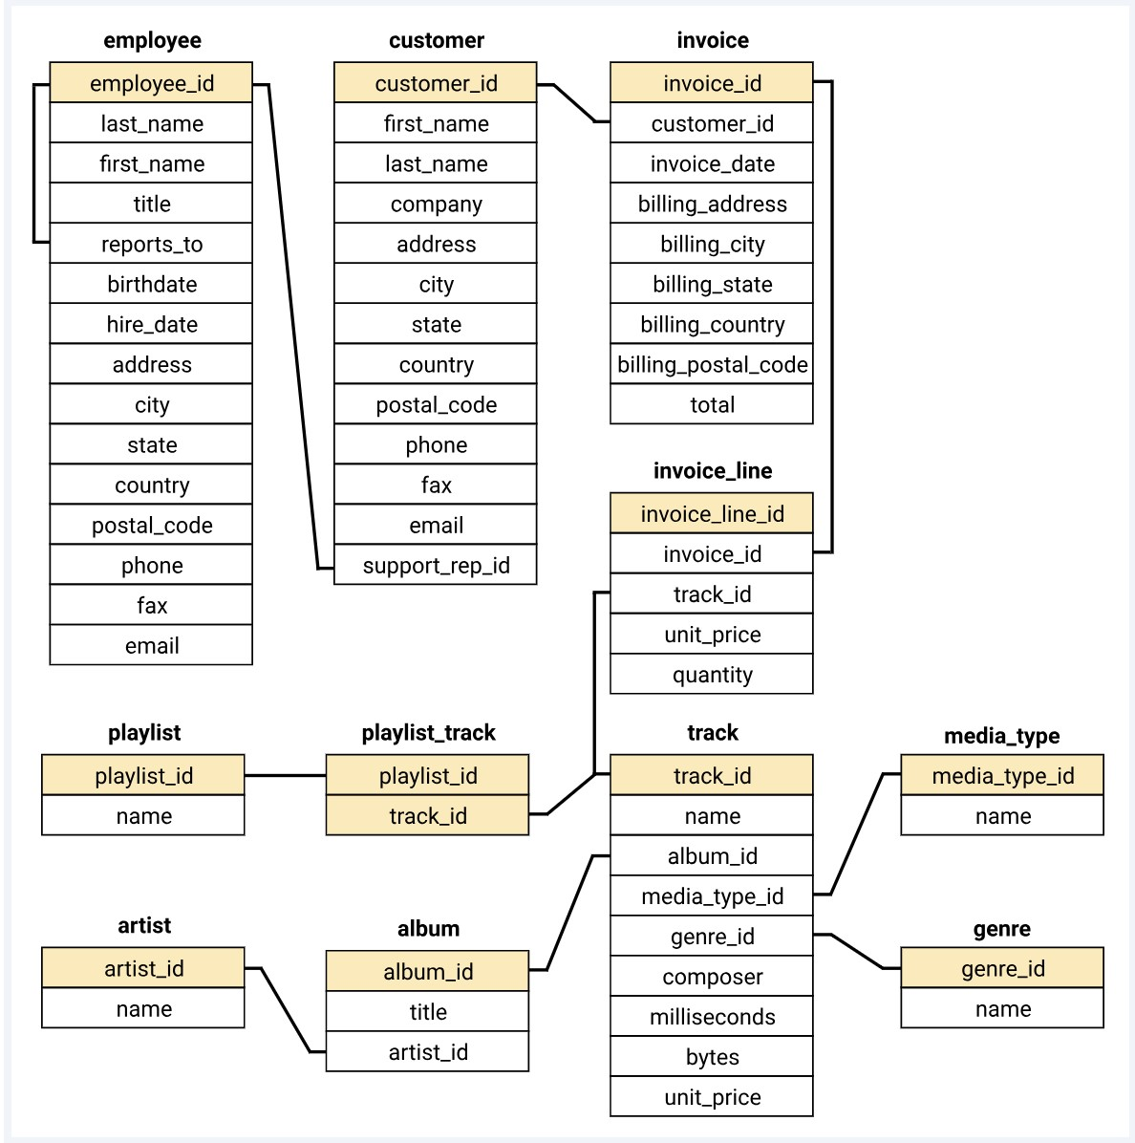

We will now solve questions based on this Music Store data that we have.

**Q1. Who is the senior most employee?**

SELECT * FROM EMPLOYEE

ORDER BY LEVELS DESC

LIMIT 1;

**Q2. Which countries have the most invoices?**

SELECT COUNT(*) AS C, BILLING_COUNTRY //ANY COLUMN COUNT() WILL WORK HERE

FROM INVOICE

GROUP BY BILLING_COUNTRY

ORDER BY C DESC

LIMIT 1;

**Q3. What are top 3 values of total invoices?**

SELECT TOTAL FROM INVOICES

ORDER BY TOTAL DESC

LIMIT 3;

**Q4. Which city has best customers? Write a query that returns one city that has all the highest sum of invoice totals. Return both the city name and sum of all invoice totals.**

SELECT BILLING_CITY, SUM(TOTAL) AS INVOICE_TOTAL

FROM INVOICE

GROUP BY BILLING CITY

ORDER BY INVOICE_TOTAL DESC

LIMIT 1;

**Q5. Who is the best customer? Write a query that returns the person who has spent the most money.**

SELECT CUSTOMER.CUSTOMERID, CUSTOMER.FIRSTNAME, CUSTOMER.LASTNAME, SUM(INVOICE.TOTAL) AS TOTAL

FROM CUSTOMER

JOIN INVOICE

ON CUSTOMER.CUSTOMERID = INVOICE.CUSTOMERID

GROUP BY CUSTOMER.CUSTOMERID

ORDER BY TOTAL DESC

LIMIT 1;

**Q6. Write a query to return the email, first name, last name and genre of all rock music listners. Return your list ordered alphabetically by email starting with a.**

SELECT DISTINCT EMAIL, FIRST_NAME, LAST_NAME

FROM CUSTOMER

JOIN INVOICE ON CUSTOMER.CUSTOMER_ID = INVOICE.CUSTOMER_ID

JOIN INVOICELINE ON INVOICE.INVOICE_ID = INVOICELINE.INVOICE_ID

WHERE TRACK_ID IN

(

SELECT TRACK_ID FROM TRACK

JOIN GENRE ON TRACK.GENRE_ID = GENRE.GENRE_ID

WHERE GENRE.NAME LIKE ‘ROCK’

)

ORDER BY EMAIL;

**Q7. Write a query that returns the artist’s name and total track count of the top 10 rock bands.**

SELECT ARTIST.ARTIST_ID , ARTIST.NAME, COUNT(ARTIST.ARTIST_ID) AS NUMBER_OF_SONGS

FROM TRACK

JOIN ALBUM ON ALBUM.ALBUM_ID = TRACK.ALBUM_ID

JOIN ARTIST ON ARTIST.ARTIST_ID = ALBUM.ARTIST_ID

JOIN GENRE ON GENRE.GENRE_ID = TRACK.GENRE_ID

WHERE GENRE.NAME LIKE ‘ROCK’

GROUP BY ARTIST.ARTIST_ID

ORDER BY NUMBER_OF_SONGS DESC

LIMIT 10;

**Q8. Return all track names that have a song length greater than the average song length. Return name and milliseconds. Order the song names with the longest songs listed first.**

SELECT NAME, MILLISECONDS

FROM TRACK

WHERE MILLISECONDS > (

SELECT AVG(MILLISECONDS) AS AVG_TRACK_LENGTH

FROM TRACK)

ORDER BY MILLISECONDS DESC;

**Q9. Write a query to return customer name, artist name and total spent.**

WITH best_selling_artist AS (

SELECT artist.artist_id AS artist_id, artist.name AS artist_name, SUM(invoice_line.unit_price*invoice_line.quantity) AS total_sales

FROM invoice_line

JOIN track ON track.track_id = invoice_line.track_id

JOIN album ON album.album_id = track.album_id

JOIN artist ON artist.artist_id = album.artist_id

GROUP BY 1

ORDER BY 3 DESC

LIMIT 1

)

SELECT c.customer_id, c.first_name, c.last_name, bsa.artist_name, SUM(il.unit_price*il.quantity) AS amount_spent

FROM invoice i

JOIN customer c ON c.customer_id = i.customer_id

JOIN invoice_line il ON il.invoice_id = i.invoice_id

JOIN track t ON t.track_id = il.track_id

JOIN album alb ON alb.album_id = t.album_id

JOIN best_selling_artist bsa ON bsa.artist_id = alb.artist_id

GROUP BY 1,2,3,4

ORDER BY 5 DESC;

**Q10. We want to find out the most popular music genre for each country. We determine the most popular genre as the genre having the highest number of purchases.**

Method 1: Using CTE

WITH popular_genre AS

(

SELECT COUNT(invoice_line.quantity) AS purchases, customer.country, genre.name, genre.genre_id, ROW_NUMBER() OVER(PARTITION BY customer.country ORDER BY COUNT(invoice_line.quantity) DESC) AS RowNo

FROM invoice_line

JOIN invoice ON invoice.invoice_id = invoice_line.invoice_id

JOIN customer ON customer.customer_id = invoice.customer_id

JOIN track ON track.track_id = invoice_line.track_id

JOIN genre ON genre.genre_id = track.genre_id

GROUP BY 2,3,4

ORDER BY 2 ASC, 1 DESC

)

SELECT * FROM popular_genre WHERE RowNo <= 1

Method 2: : Using Recursive

WITH RECURSIVE sales_per_country AS(

SELECT COUNT(*) AS purchases_per_genre, customer.country, genre.name, genre.genre_id

FROM invoice_line

JOIN invoice ON invoice.invoice_id = invoice_line.invoice_id

JOIN customer ON customer.customer_id = invoice.customer_id

JOIN track ON track.track_id = invoice_line.track_id

JOIN genre ON genre.genre_id = track.genre_id

GROUP BY 2,3,4

ORDER BY 2

),

max_genre_per_country AS (SELECT MAX(purchases_per_genre) AS max_genre_number, country

FROM sales_per_country

GROUP BY 2

ORDER BY 2)

SELECT sales_per_country.*

FROM sales_per_country

JOIN max_genre_per_country ON sales_per_country.country = max_genre_per_country.country

WHERE sales_per_country.purchases_per_genre = max_genre_per_country.max_genre_number;

**Q11. Write a query that determines the customer that has spent the most on music for each country. Write a query that returns the country along with the top customer and how much they spent. For countries where the top amount spent is shared, provide all customers who spent this amount.**

Method 1: using CTE

WITH Customter_with_country AS (

SELECT customer.customer_id,first_name,last_name,billing_country,SUM(total) AS total_spending,

ROW_NUMBER() OVER(PARTITION BY billing_country ORDER BY SUM(total) DESC) AS RowNo

FROM invoice

JOIN customer ON customer.customer_id = invoice.customer_id

GROUP BY 1,2,3,4

ORDER BY 4 ASC,5 DESC

)

SELECT * FROM Customter_with_country WHERE RowNo <= 1

Method 2: Using Recursive

WITH RECURSIVE

customter_with_country AS (

SELECT customer.customer_id,first_name,last_name,billing_country,SUM(total) AS total_spending

FROM invoice

JOIN customer ON customer.customer_id = invoice.customer_id

GROUP BY 1,2,3,4

ORDER BY 2,3 DESC),

country_max_spending AS(

SELECT billing_country,MAX(total_spending) AS max_spending

FROM customter_with_country

GROUP BY billing_country)

SELECT cc.billing_country, cc.total_spending, cc.first_name, cc.last_name, cc.customer_id

FROM customter_with_country cc

JOIN country_max_spending ms

ON cc.billing_country = ms.billing_country

WHERE cc.total_spending = ms.max_spending

ORDER BY 1;